Test Case: tc002_SPX_Dev5_Crear_Requisicion_Spot_Tipo_Cobro_Project
Step 1 - Enter username and password and click to button Enter: Credentials Entered
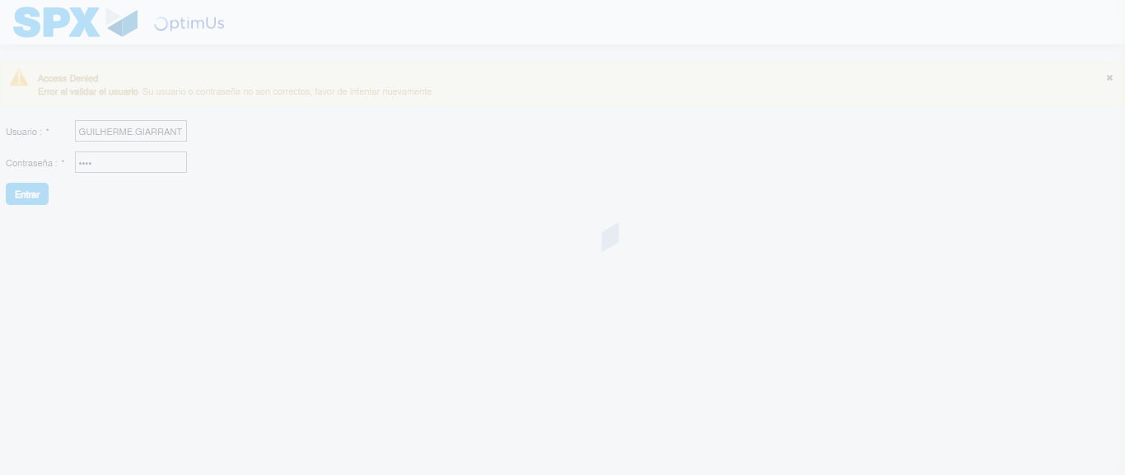Image file-name: QC_Testing-tc002_SPX_Dev5_Crear_Requisicion_Spot_Tipo_Cobro_Project-1784309536566

Step 2 - Select to UEN and Access to Spot Buy Requisitions : UEN Correctly selected and Correct access
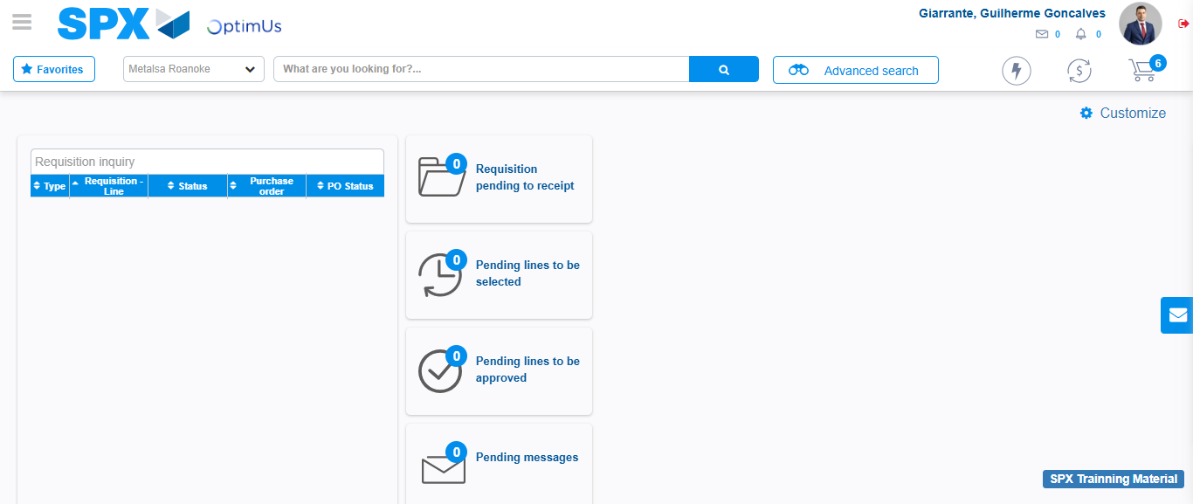Image file-name: QC_Testing-tc002_SPX_Dev5_Crear_Requisicion_Spot_Tipo_Cobro_Project-1784309606670

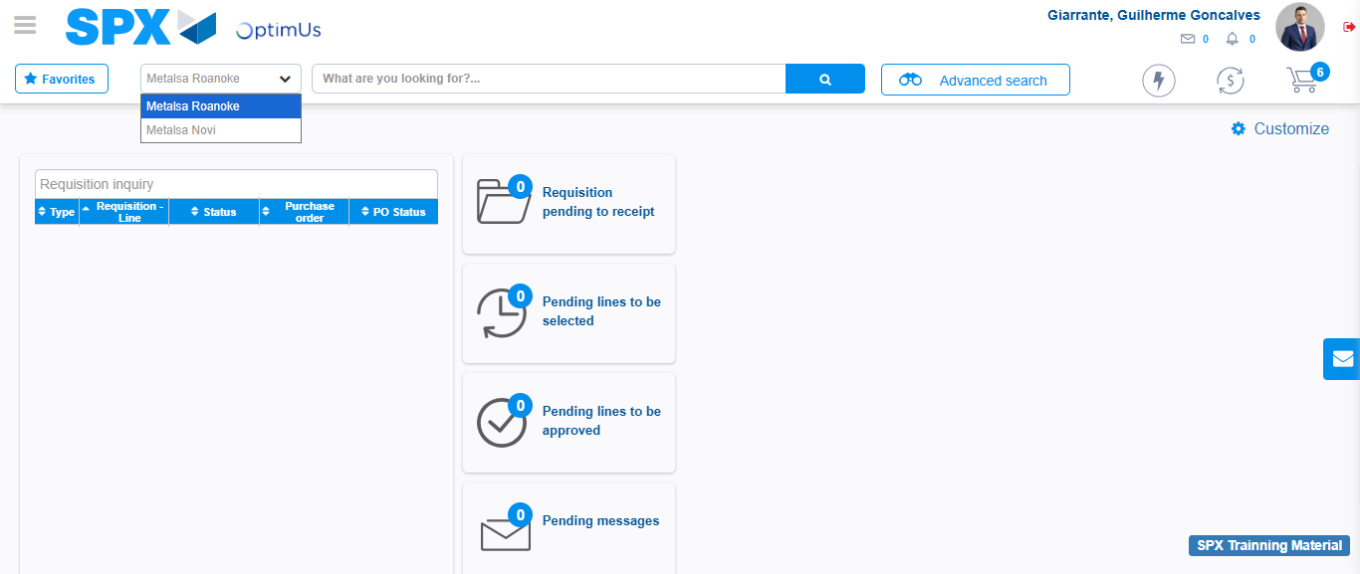Image file-name: QC_Testing-tc002_SPX_Dev5_Crear_Requisicion_Spot_Tipo_Cobro_Project-1784309609227

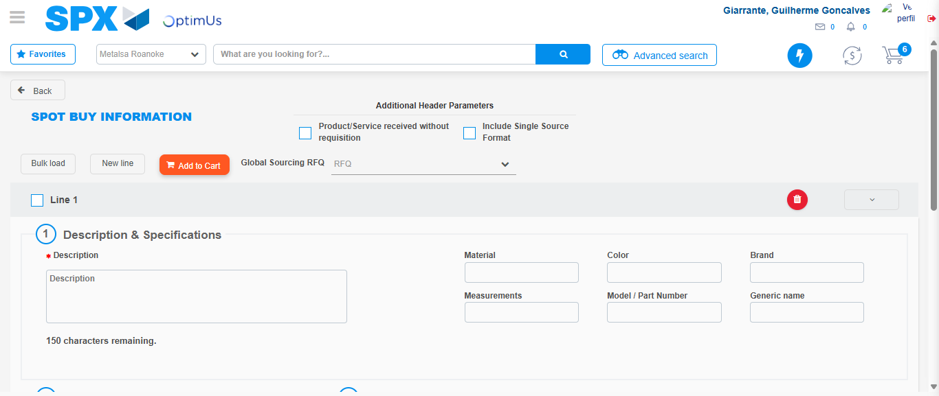Image file-name: QC_Testing-tc002_SPX_Dev5_Crear_Requisicion_Spot_Tipo_Cobro_Project-1784309614833

Step 3 - Data Capture Spot Buy Requisition: Data captured correctly
Image file-name: QC_Testing-tc002_SPX_Dev5_Crear_Requisicion_Spot_Tipo_Cobro_Project-1784309615120

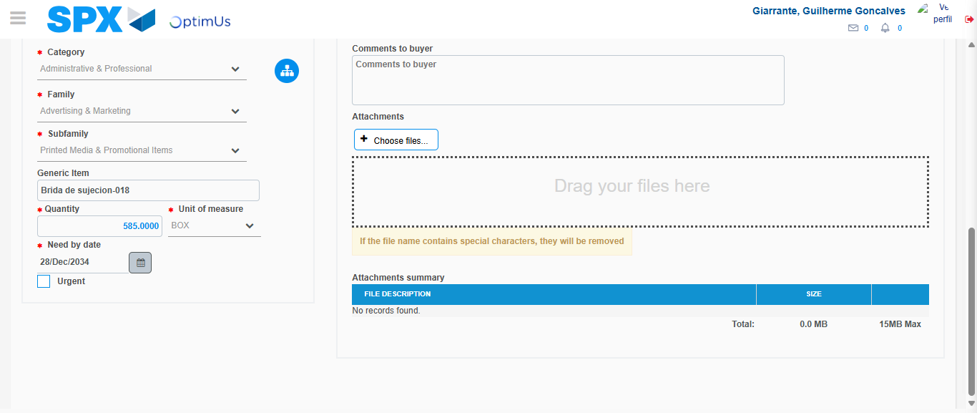Image file-name: QC_Testing-tc002_SPX_Dev5_Crear_Requisicion_Spot_Tipo_Cobro_Project-1784309626118

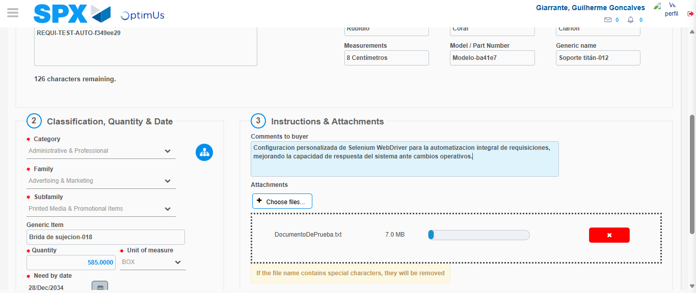Image file-name: QC_Testing-tc002_SPX_Dev5_Crear_Requisicion_Spot_Tipo_Cobro_Project-1784309627058

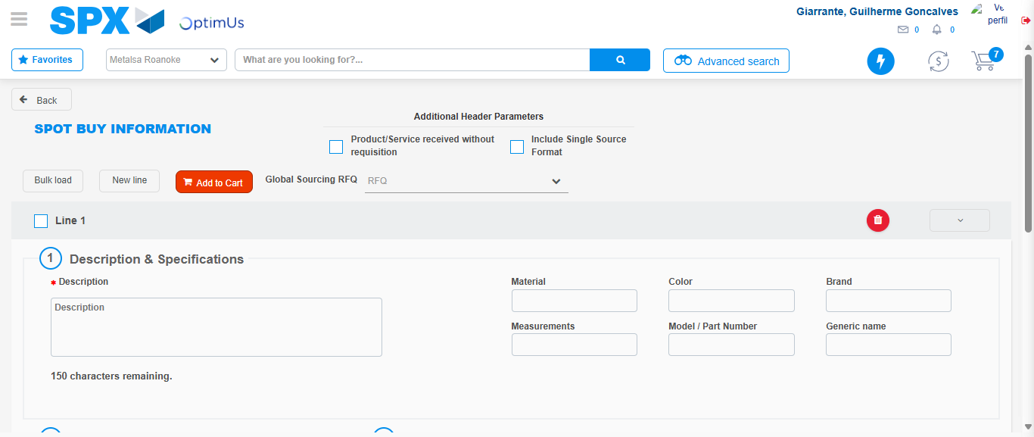Image file-name: QC_Testing-tc002_SPX_Dev5_Crear_Requisicion_Spot_Tipo_Cobro_Project-1784309632209

Step 7 - Return to Main Page SPX : Return to Main Page SPX
Image file-name: QC_Testing-tc002_SPX_Dev5_Crear_Requisicion_Spot_Tipo_Cobro_Project-1784309606670

Image file-name: QC_Testing-tc002_SPX_Dev5_Crear_Requisicion_Spot_Tipo_Cobro_Project-1784309609227

Image file-name: QC_Testing-tc002_SPX_Dev5_Crear_Requisicion_Spot_Tipo_Cobro_Project-1784309614833

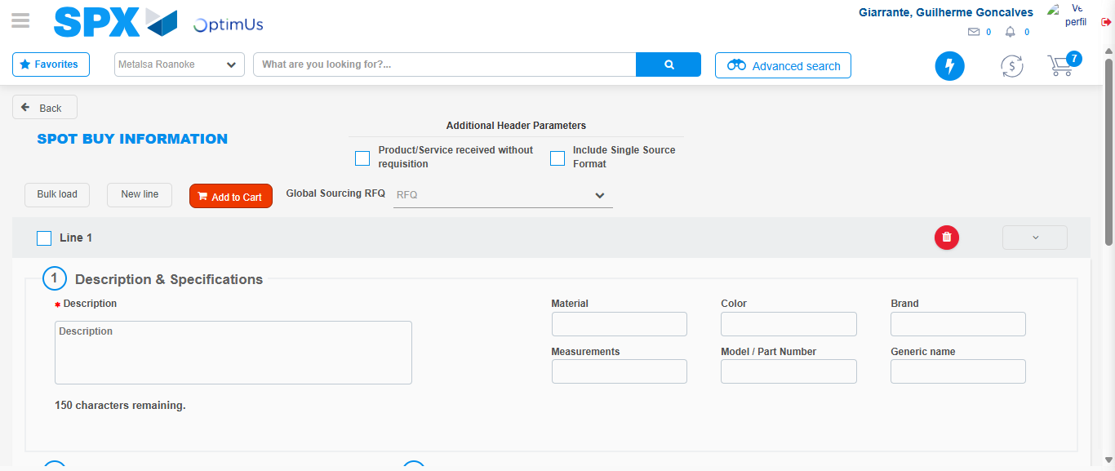Image file-name: QC_Testing-tc002_SPX_Dev5_Crear_Requisicion_Spot_Tipo_Cobro_Project-1784309634508

Image file-name: QC_Testing-tc002_SPX_Dev5_Crear_Requisicion_Spot_Tipo_Cobro_Project-1784309634733

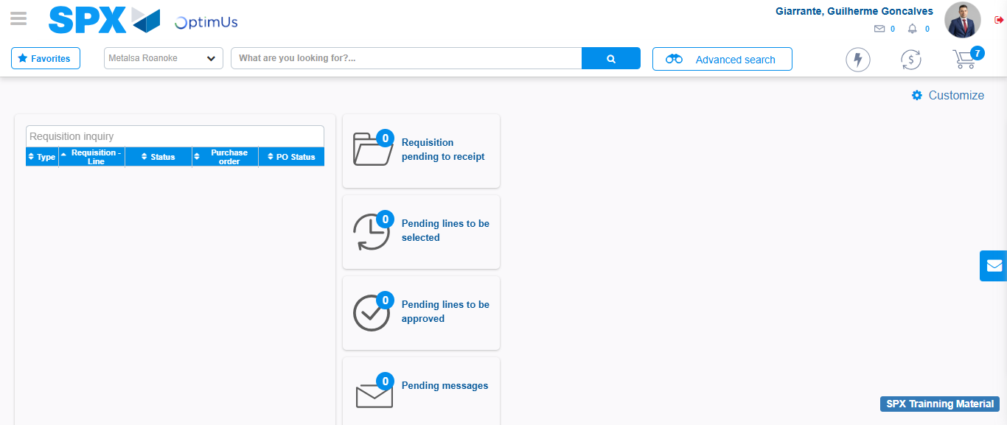Image file-name: QC_Testing-tc002_SPX_Dev5_Crear_Requisicion_Spot_Tipo_Cobro_Project-1784309655969

Step 8 - Log Out : Log Out SPX
Image file-name: QC_Testing-tc002_SPX_Dev5_Crear_Requisicion_Spot_Tipo_Cobro_Project-1784309656242

